Walker Evans’s Cuba,
via Ernest Hemingway
By David Gonzalez Nov. 7, 2017Nov. 7, 2017
It seems fitting that during Walker Evans’s one-month stay in Havana in 1933 he would befriend Ernest Hemingway. The two shared an appreciation of a spare style that would influence countless others in photography and literature. In fact, Evans entrusted Hemingway with a trove of original prints to ensure they would not be confiscated by the authorities who were violently suppressing popular outrage against the dictator Gerardo Machado.
Now, 46 of those vintage prints are being sold by DeWolfe and Wood Rare Books of Alfred, Me., and Michael Brown Rare Books of Philadelphia, and are featured in a catalog whose comprehensive introductory essay was written by Mr. Brown. The collection is owned by Benjamin Bruce, known as Dink. His father, Telly Otto Bruce, known as Toby, was Hemingway’s friend and factotum and had safeguarded the images for decades in Key West, Fla., where Hemingway had lived.
Photo
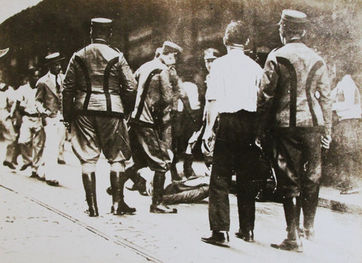
"Melee with policemen and civilians." 1933.Credit Estate of Walker Evans/The Metropolitan Museum of Art, New York
Evans had gone to Cuba to make pictures for “The Crime of Cuba,” a book by Carleton Beals that was a fierce critique of American adventurism. “The Beals book is an expose of our misgovernment in Cuba, and the disgraceful part we have played in her tragic history past and present, economic, social, political,” read the review in Kirkus. “Sins of omission perhaps even more than sins of commission. The story of Cuba is the story of tyranny-Spain, the United States, Wall Street, and now, closely linked with the immediate past, the dictatorship of Machado, which makes Mussolini look like a Sunday School picnic.”
Evans got a taste of that supercharged political climate in his earliest days there, according to Mr. Brown’s essay, where a bus ride could turn into a journey of intrigue as who-knows-who was tailing him as he tried to meet with opposition figures. At the same time, the city thrilled him.
“When you are still bewildered,” Evans wrote in his diary, “you notice more things, as in a drunk. I was drunk with a new city for days.”
That feeling became literal when he met Hemingway, likely through an introduction by one of Beals’s newspaper contacts on the island. “I had a wonderful time with Hemingway,” Evans was quoted in the catalog’s essay. “Drinking every night. He was at loose ends … and he needed a drinking companion, and I filled that role for two weeks.”
Photo
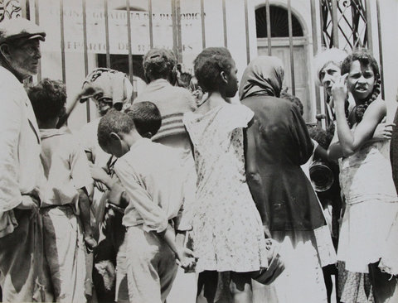
“Breadline, Havana.” 1933.Credit Estate of Walker Evans/The Metropolitan Museum of Art, New York
But as the essay also noted, Hemingway’s prose style may have had an influence on Evans, whose vision had been influenced earlier by a stay in Paris, where he came to appreciate the work of Eugène Atget. The images — out of a total of 400 taken during his one-month sojourn, betray that influence in photos of facades and streets. Some of them show more isolated, intimate scenes in public, from a haggard looking country family to beggars. In several images, Evans copied grisly newspaper images of people killed by Machado’s forces.
The politically-charged atmosphere led Evans to give Hemingway the prints that would, in turn, be taken to Key West by boat. Once there, the images ended up in storage either behind, or next to, Sloppy Joe’s, the famous Key West saloon.
“The humidity of Key West made a lot of things a little ripe, but the photos are beautiful,” Scott DeWolfe said. “What is fascinating is I think Evans was printing these where he was able to. Unlike later prints, most of these are uncropped, and slightly different. One print has Evans’s thumbprint. It’s as close to a first generation print you could possibly find.”

